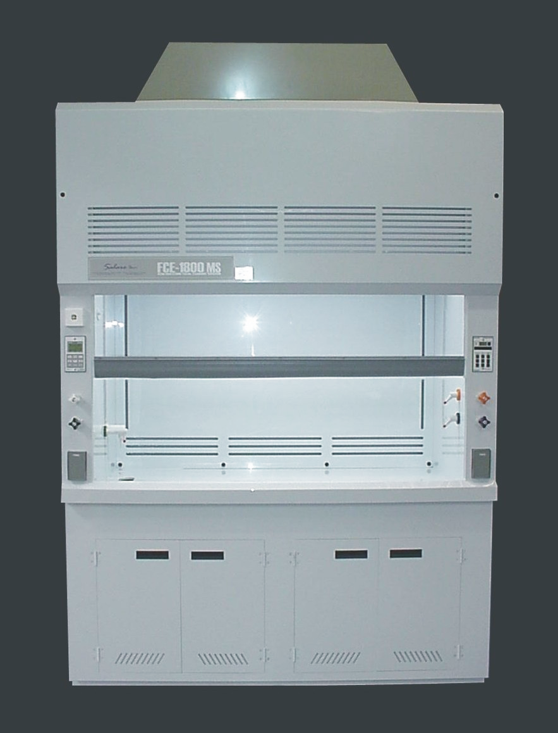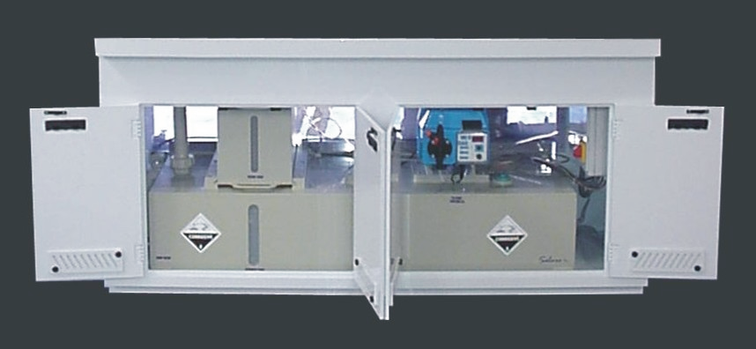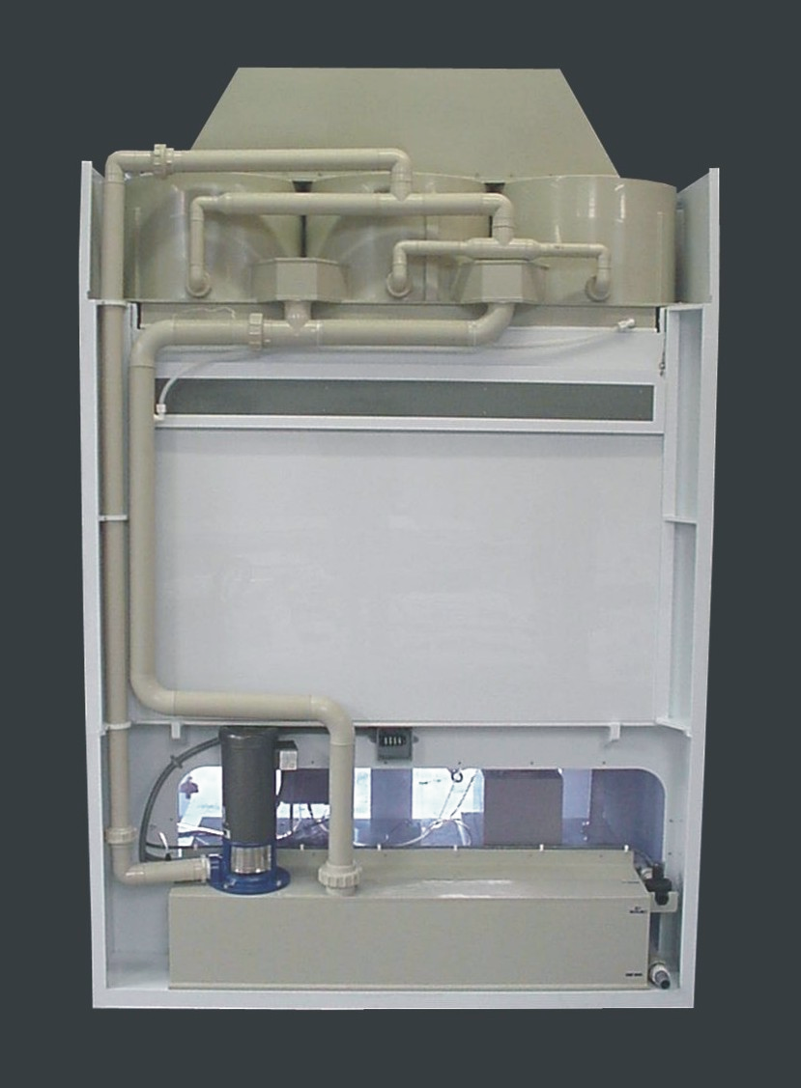
High Performance
Low Maintenance
Safety
Quality
Craftsmanship

Maelstrom Fume Hood Compact Scrubbers
TM

Technical Specification
Models M60, M120, and M180

Table of Contents

Maelstrom™ Fume Hood Compact Scrubbers
Introduction
Applications
Operation
Removal performance
Maelstrom™ Scrubber Configuration
Scrubber Controls
Scrubber Components
Liquid supply pipes
Inlet plenum
Outlet plenum
Gas pressure drop
Sump Components
Service connections
pH dosing and control system
Concentrate storage vessel
Recommended concentrates
Further Information

1 Maelstrom™ fume hood compact scrubbers

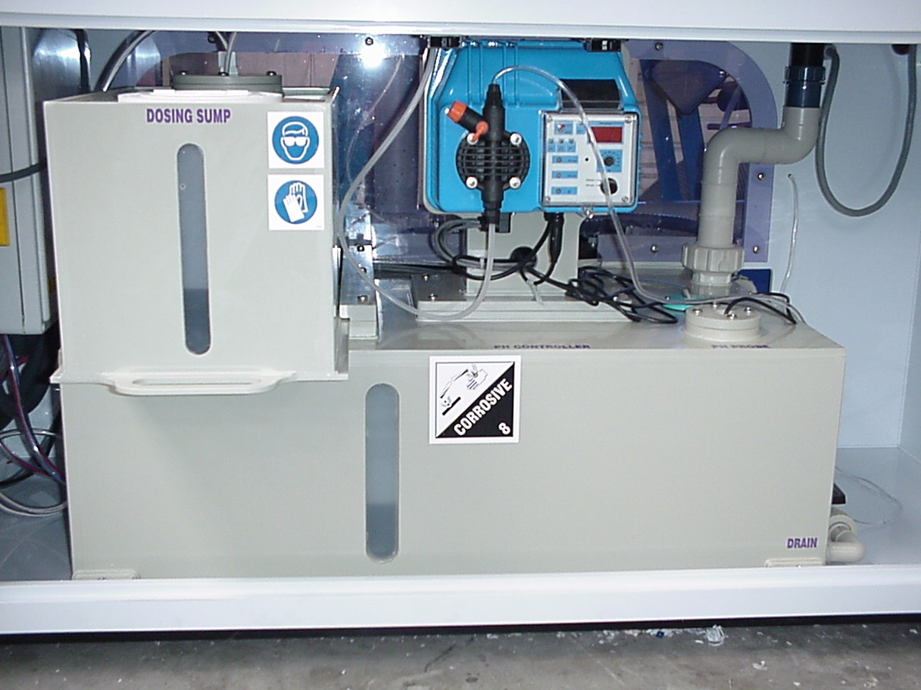
Introduction
- Removal efficiencies greater than 98% may be achieved on most gaseous contaminants such as acid or alkali gases, halogens and other soluble contaminants.
- Approaching 100% efficiency at removing solid particles greater than 10 microns in size.
- 50% smaller than conventional packed column scrubbers for the same gas flow rate.
- Empty internal structure, no packing or demisters to foul, block or corrode. Typical Fume Hood with Maelstrom™ Scrubber
- Self cleaning, essentially maintenance free design and operation thanks to unique unblockable CobraSpray™ nozzles.
- Infinite gas side turn-down ratio, allowing a wide operating flow rate range per system, even over fluctuating flowrates.
- Low gas side turn-down ratio, typically 3.2”WG (800Pa) for the majority of applications.
- Highly flexible and adaptable system can be upgraded from standard specification to accommodate higher gas flow rate and increased removal efficiency, thus keeping pace with your growing process ventilation requirements.
- Economic, self-contained modularised systems provide you with a rapid and convenient pre-packaged system to treat your air pollution challenges.
- Available in a range of corrosion resistant material to suit you specific environment.

The Maelstrom™ range of fume hood compact scrubbers has been specifically designed for laboratory fume hoods and is therefore kept as simple and compact as possible. The patented technology employed by Maelstrom™ scrubbers is the same as is used on the larger range of industrial scrubbing systems as supplied to the chemical, pharmaceutical and other industries.

This well proven and robust vortex scrubbing technology provides efficient and intense mass transfer in the absence of any packing as would normally be present in conventional scrubbing systems. This allows efficient operation with potentially fouling/clogging applications and is important where solids removal or salt precipitation is anticipated. The accumulation of insoluble solids in the scrubbing liquor poses no threat of blockage for the Maelstrom™ scrubber.

Because of its inherent robustness this Maelstrom™ scrubbing unit will give many years of reliable, highly efficient and trouble free service.

Applications

The Maelstrom™ range of compact fume hood scrubbers is designed to absorb aggressive and toxic gases and vapors, such as perchloric acid, hydrogen fluoride, sulphuric acid, hydrogen chloride and nitric acid and the vapors of such mixtures as aqua regia immediately after they are formed. The scrubbing of such gases occurs within the confines of the fume hood before the gas is exhausted into the ductwork and so protects valuable building ventilation systems.

If the fume hood’s cup sink (optional item on some fume hoods) is connected directly to the Maelstrom™ sump vessel, any liquid disposed of via the cup sink will be subject to a pH correction according to the value set on the pH dosing pump. This can be useful if quantities of acid or alkali solutions are regularly used within the fume hood, and are not permitted to be disposed of directly to drain without treatment.

OPERATION
The gas containing the contaminants enters the Maelstrom™ scrubber via a tangential entry port into the vortex chamber. The gas is forced to accelerate towards the central axial outlet port of this chamber as it spins in a cyclone or ‘vortex’ pattern. The scrub liquor is sprayed into this chamber via the CobraSpray™ nozzles located at the center of the chamber. The gas must pass through the network of finely divided droplets before it can exit through the central outlet port at the top of the chamber.

The high relative velocities between the gas and liquid phases ensure that there is maximum opportunity for mass transfer and therefore absorption of the contaminants.

The gas then passes into a droplet disengagement section where any droplet carry-over is removed through a rapid decrease in velocity (Note – this disengagement section is not as fragile or sensitive to blockage as a traditional demister). The cleaned gas is then re-accelerated and discharged directly to atmosphere.

The scrub liquor from both the main vortex chamber and the disengagement section drains back under gravity to the integral sump where it is recirculated back through the CobraSpray™ nozzles for reuse. A constant removal and replenishment of the scrub liquor (termed ‘blow-down’) will be required in order for the scrubber to operate continuously. As a cost option fully automatic chemical dosing facilities can be supplied on request.
The addition of a second or third vortex chamber stage in either parallel or series configuration will have the effect of either doubling the maximum gas flow rate capacity or doubling the scrubbing factor of the system respectively.

Removal performance
The Maelstrom™ range of fume hood scrubbers is designed to treat a wide range of acids and alkalis, and will be effective in removing dust and particulates greater than 10microns in size. As a guide the following performance figures for a standard specification Maelstrom system can be achieved:

- Sulphur dioxide (SO₂): up to 97% removal
- Hydrochloric acid (HCl): up to 98% removal
- Ammonia (NH₃): up to 98% removal
- Perchloric acid (HClO₄): up to 98% removal
- Hydrogen fluoride (HF): up to 99% removal
- Sulphuric acid (H₂SO₄): up to 98% removal
- Nitric acid (HNO₃): up to 93% removal

Maelstrom™ Scrubber Configuration
The scrubber and sump vessel come in two separate sections connected by the liquid supply pipework located to the rear of the fume hood into which the system is mounted. The scrubber section comprising inlet plenum, vortex scrubbing chambers, disentrainment sections and collection sump is located in the header section of the fume hood. The sump section containing the liquor recirculation pump, sump vessel, distribution pipework, fill and drain connections, overflow and pH controller and ancillaries is located underneath the workbench area of the fume hood.
The range of Maelstrom™ fume hood scrubbers comprises:

 | Maelstrom™  M60 | Maelstrom™  M120 | Maelstrom™  M180
Max. air flowrate | 490 m³/hr (290cfm) | 980 m³/hr (576cfm) | 1,470 m³/hr (865cfm)
Max. installation dims.* | 593 x 744 x 467 mm | 1180 x 744 x 467 mm | 1767 x 744 x 467 mm
Max. pressure drop | 800 Pa (3.2”WG) | 800 Pa (3.2” WG) | 800 Pa (3.2”WG)
Scrubber weight (dry) | 14.5kg (32lbs) | 29kg (64lbs) | 43.5kg (96lbs)
Scrubber weight (wet) | 39kg (86lbs) | 46kg (101lbs) | 69kg (152lbs)
Gas outlet connection | 1 x 200 mm dia.(8”) | 1 x 250 mm dia.(10”) | 2 x 250 mm dia.(10”)
Fume hood suitability | 1.0 m, (3’) | 1.2 m, 1.5 m (4’& 5’) | 1.8 m (6’)
* Includes exhaust outlet plenum chamber

Scrubber controls
The scrubber control panel (which can be mounted anywhere on the fume hood) comprises the main scrubber controls, main pH dosing pump controls, pH meter, (optional wash-down controls) and alarm functions and comes complete with an built-in audible alarm.

- Scrubber ‘On’ button with green LED.
- Scrubber ‘Off’ button with red LED.
- pH pump ‘On’ button with green LED.
- pH pump ‘Off’ button with red LED.
- Washdown ‘On’ button with green LED (This function optional on some models).
- Washdown ‘Off’ button with red LED (This function optional on some models).
- Sump empty warning LED (red).
- pH dosing concentrate tank empty warning LED (red).
- General alarm/mute LED (red) [indicating either: sump or concentrate tank empty].
- Sump pH value (mimic from pH dosing pump controls).
- pH level out of limit (mimic from pH dosing pump controls).

Scrubber components

Liquid supply pipes
The liquid supply pipes between the scrubber chambers and sump unit are located to the rear of the fume hood assembly. These pipes are usually assembled, connected and leak tested at the factory and should require no user adjustments or user service.

Inlet plenum
The scrubber inlet plenum directs the extracted air from the rear of the fume hood up into the scrubber unit for even distribution into the cyclonic scrubbing chambers. As an optional extra a wash-down system comprising spray nozzles, solenoid inlet valve and controls can be built into the inlet plenum. This will ensure that in the event of the fume hood being used for perchloric acid, a complete wash-down of ALL surfaces is achieved thus reducing the risk of solids/contamination build-up within the inlet plenum.

Outlet plenum
The removable outlet plenum located on the top surface of the scrubber section is provided to direct the cleaned extracted air rearwards into the ducting header system. It is not recommended that any other outlet connection other than the one provided with the scrubber is used, as this may have a detrimental effect on the air flow within the scrubber unit. The entire outlet plenum chamber is removable to assist in installing and positioning the fume hood, and can be rotated through 180° such that the outlet flanges are directed forwards if required. No adjustments or user service is required to this item, unless the cupboard is relocated from its original installation location.

The number and size of the outlet flanges on the outlet plenum chambers vary depending on the model of scrubber used:

Model | Number of  Flanges | Nom. Dia.  of Flange
M60 | 1 | 200mm/ 8”
M120 | 1 | 250mm/ 10”
M180 | 2 | 250mm/ 10”

Gas pressure drop
The maximum airflow pressure drop experienced through a Maelstrom™ scrubber should not exceed 800 Pa. (3.2” WG) at its maximum rated flowrate.

Sump components

Service connections
The standard under-bench sump unit provides storage for the scrubber liquor, pH control and dosing pump, concentrate storage vessel, pH probe, electrical switch box and scrub liquor distribution pipework.

 | Maelstrom™ Compact sump Unit
Scrubber suitability | M60 | M120 | M180
Max. installation dimensions* | 990 x 720 x 760mm
Nominal sump capacity | 180 litres (48 US Gal)
Concentrate vessel capacity | 20 litres (5.2 US Gal)
Fresh water fill connection | ¾” BSP(F) via NC solenoid valve
Drain connection | 1 ½” BSP(M) via manual ball valve
Drip cup connection | 1 ½” BSP(M)
Operating temp. range | 10ºC - 70ºC (50ºF - 158ºF)
pH probe type | BNC connector
PH measurement | 0 – 14 pH (±0.1 pH unit)
Max. dosing pressure | 10 bar (145psi)
Max. noise level | 70 dB[A]
Weight (dry) | 80kg (176lbs)
Weight (wet) | 265kg (584lbs)
Electrical supply | 240v, 1ph, 60Hz or 220v, 1ph, 50Hz
Max. Power consumption | 0.82 kW | 1.15 kW | 1.55 kW
* This excludes pipework overhang on models M120 and M180.

pH dosing and control system
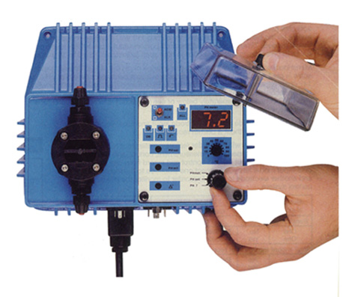
The pH control system on the Maelstrom™ scrubber sump ensures that the pH level of the scrubbing liquor remains constant by continuously measuring the prevailing pH of the sump contents and injecting concentrate directly into the scrubbing liquid just prior to it entering the scrubbing chamber. This ensures that maximum absorption and neutralization capability of the scrubber is maintained during even the harshest and most contaminated conditions. This dosing action is logarithmically proportional and as such will occur at a maximum injection rate until the measured pH value comes within two units of the set point. At this stage the pump gradually reduces the injection rate and eventually comes to a complete standstill when the set point is reached.

The dosing system will isolate itself (and activate an audio visual alarm on the control panel) in the event that the level of concentrate in the concentrate storage vessel drops below a set level; thus giving dry-run protection. For ease of filling and replenishment of the concentrate the concentrate storage vessel slides out from underneath the workbench to provide unrestricted access to the filling port - the concentrate storage vessel holds a nominal 20 litres of concentrate.

Concentrate storage vessel
The concentrate storage vessel located underneath the workbench area of the fume hood holds a nominal volume of 20 litres (5.2 US Gal) of required acid or alkali concentrate as appropriate. To facilitate ease of access for filling, this vessel slides out from the sump unit.

Filling the Concentrate Storage Vessel

Recommended concentrates

It is recommended that solutions of up to 20% Sulphuric Acid (H₂SO₄), or 10% Sodium Hydroxide (NaOH) be used for acid or alkali dosing respectively. Other acids and bases may be used if more convenient; however they must be compatible with polypropylene, stainless steel and PVC.

Further information
For further information contact:

Salare, Inc.
PO Box 583
88 Parham Spring Lane
Henderson
NC 27536
USA

Tel: (252) 431-1208
Toll Free: (800) 293-1004
Fax: (252) 430-0025
Email: sales@salareinc.com
Web: www.salareinc.com

